MACH4METAL

metalworking machinery
Transito 21
6909 DA BABBERICH Netherlands
Tel. +31 (0)316-247123
Fax: +31 (0)316-247956
info@mach4metal.com
www.mach4metal.com

Bank No : 66.52.13.883
IBAN : NL33 INGB 0665 2138 83
BIC : INGBNL2A

CNC Press brake DARLEY 1550 x 50 T
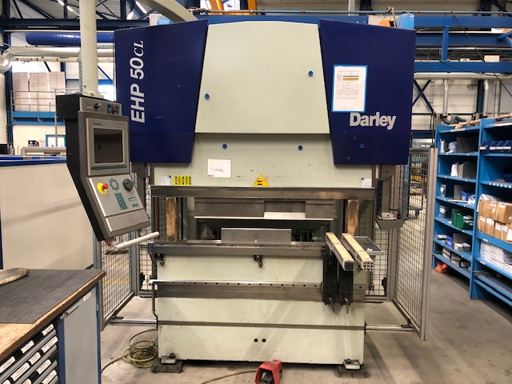
- Merk : Darley Holland
- Type : EHP-LS 50.15 CL
- Mach. No : 12.2583
- YOP : 2010

- Max. bending length : 1.550
- Between column : 1.250
- Max. force Ton : 50

- Troth : 400
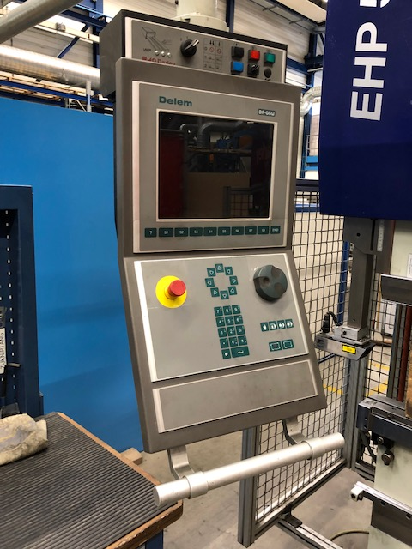
- Max. stroke : 225
- Die height : 410

- Approach speed : 200 mm/sec.
- Pressing speed : mm/sec.
- Return speed : .. mm/sec.

- CNC Delem DA 66 W
- Hydraulic tool clamp
- Laser safe
- Wila BIU-021 28° R=1 H=163
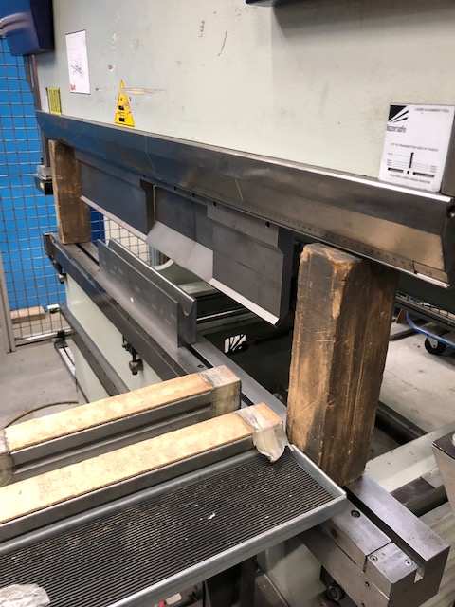
- Wila BIU-023 86° R=1 H=163
- Wila V12 / V20 / V30 / V40

- Dimensions
- Length : 2.500
- Width : 1.800
- Height : 2.500
- Weight : 4.000
- Power : 8.5 kW
- Oil tank : 110 L

Please Note: The above information has been obtained to the best of our ability and belief from, and from the manufacturers where possible. It is given in good faith, but its accuracy can not be guaranteed. Accordingly, it will not form a representation or constitute contractual terms. We advise you to check any vital details!

